Fiero Review | 6.30.11 | Natalie Pyron

Tested in FF5

1. Sign In/Create account page:
   1. The page is mis-aligned. We need to remove the far left column where 5-star favorites is shown.
   2. The 728x90 ad should be disabled.
   3. RealArcade messaging should be removed, and “Have an account?” should be aligned with New to GameHouse?
   4. Remove the extra line after the last benefit bullet: “Live-chat Customer Support”
   5. Newsletter should be pre-checked (opt-out) and the checkbox should be aligned with the form fields boxes and Register button (move a couple pixels left).
   6. Need to add more space between the checkbox and register button, ~20px (see Zack).
   7. The styling of the breadcrumbs is not accurate. Refer to production. Also, the marketing text under the nav should not be on every page (recently released). The breadcrumbs should take the place of this (current Bling sprint?).
   8. There’s a mix between Arial and Verdana used. We should just use Arial. For example, the header “New to GameHouse?” and “Have an account?” need to be changed to Arial.
   9. Remove the extra line separator after “Privacy Policy”

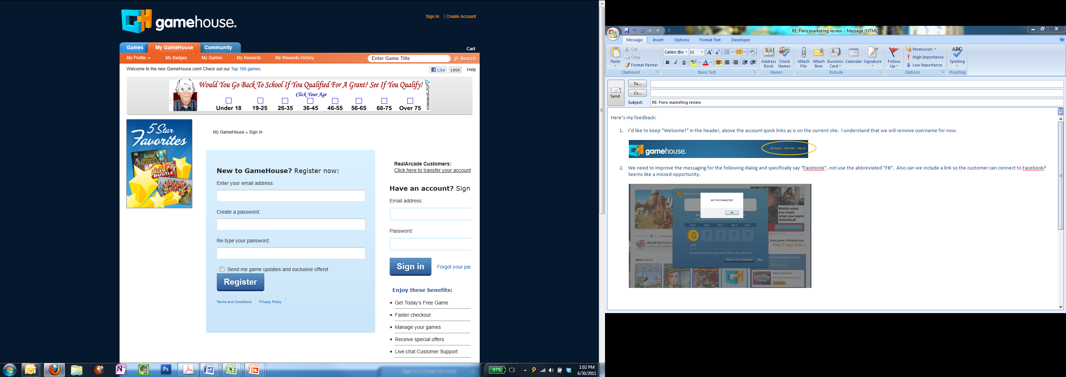

1. From the Sign In/Create Account page, when you click on Terms & Conditions and Privacy Policy, both pages are loading in an iframe showing the header twice. Refer to production: <http://www.gamehouse.com/notices>

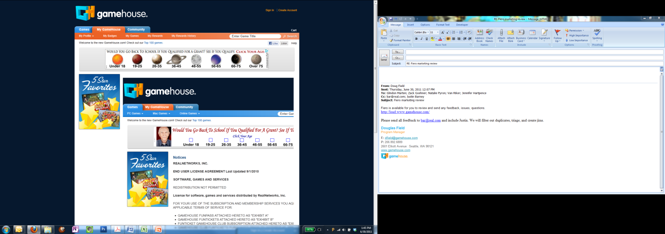

1. Can we update the logo on the FYP page in time for release?

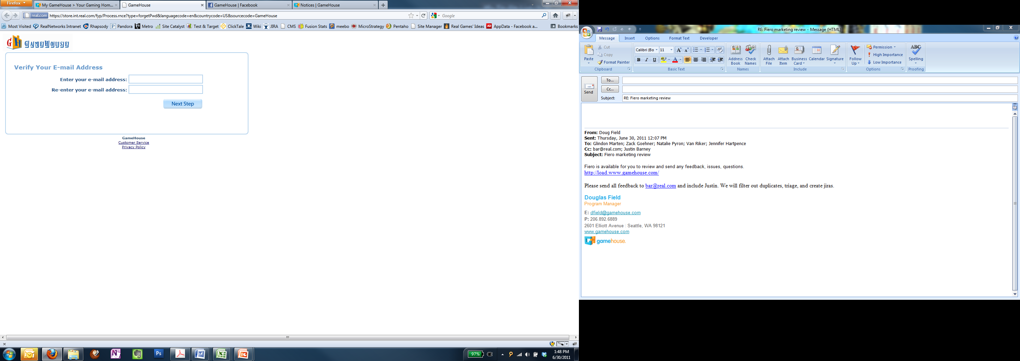

1. I’d like to keep “Welcome!” in the header, above the account quick links as is on the current site. I understand that we will remove username for now.

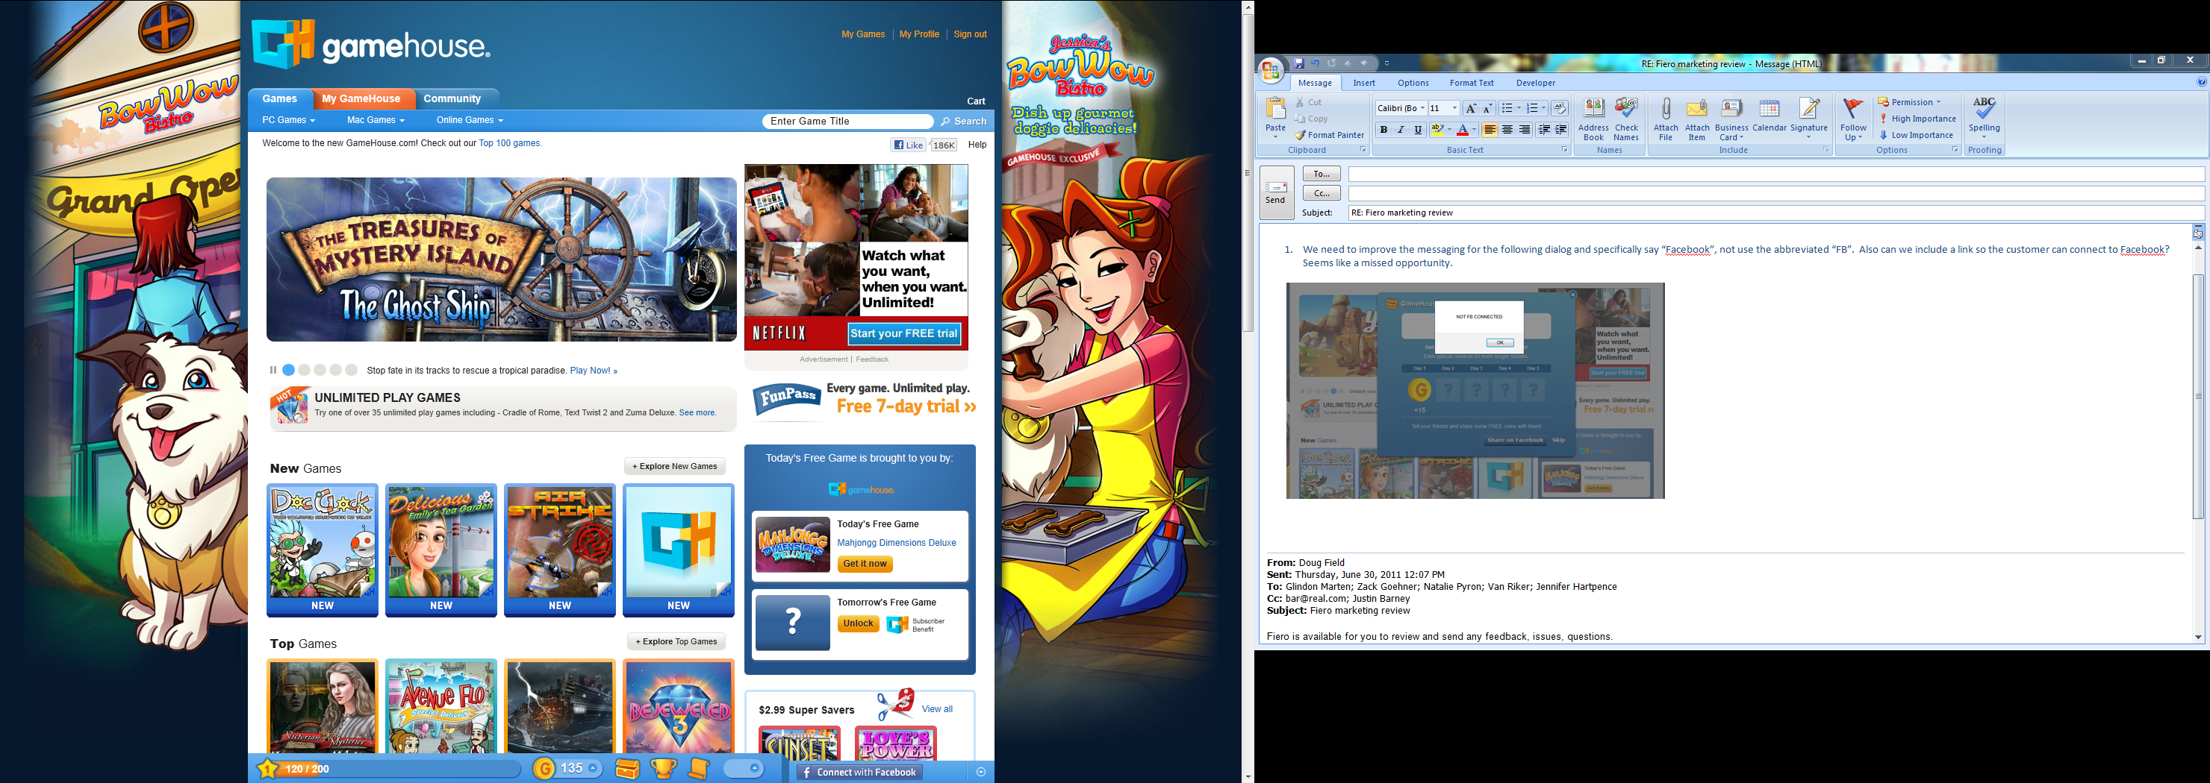

1. Tutorial: Slide 2
   1. For slide 2, I think we need to remove copy since this is no longer true: “Even better, you can share coins with friends on Facebook. Like I always say, sharing is caring.” (Justin to confirm.)
   2. For slide 2, there also needs to be space added between the copy and line separator (see Zack).

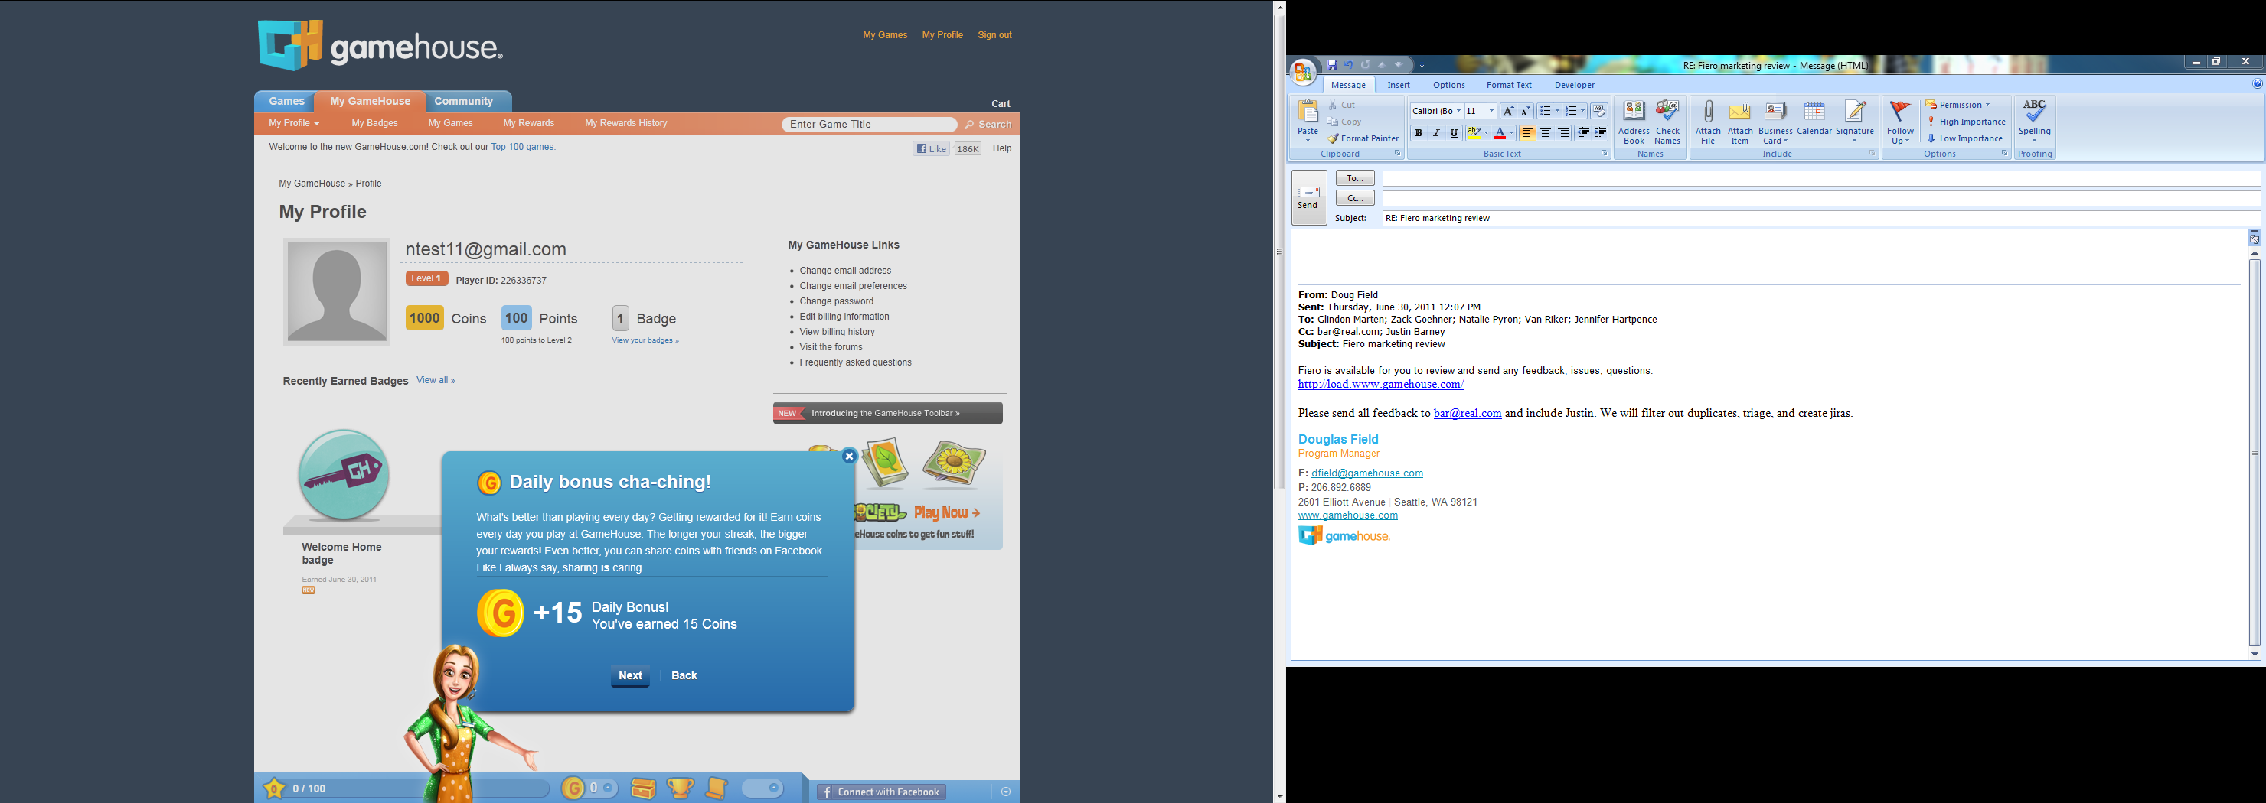

1. After completing the tutorial, I received a toast that said I reached level 2 and right after I received another toast that said I reached level 1. I think this may be a bug.
2. On the Daily Login bonus, I think we need to remove or modify the message “Tell your friends and share some FREE coins with them!” (Justin to confirm, Jen to provide copy).

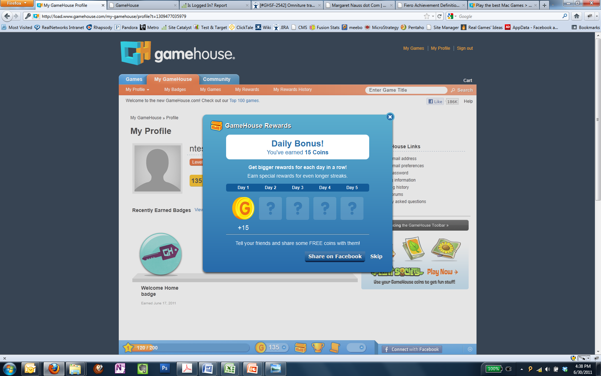

1. We need to improve the messaging for the following dialog and specifically say “Facebook” (see Jen). We should never use the abbreviated “FB” in consumer-facing messages. Do we need to provide a design for this dialogue?

Also can we include a link so the customer can connect to Facebook? Seems like a missed opportunity.

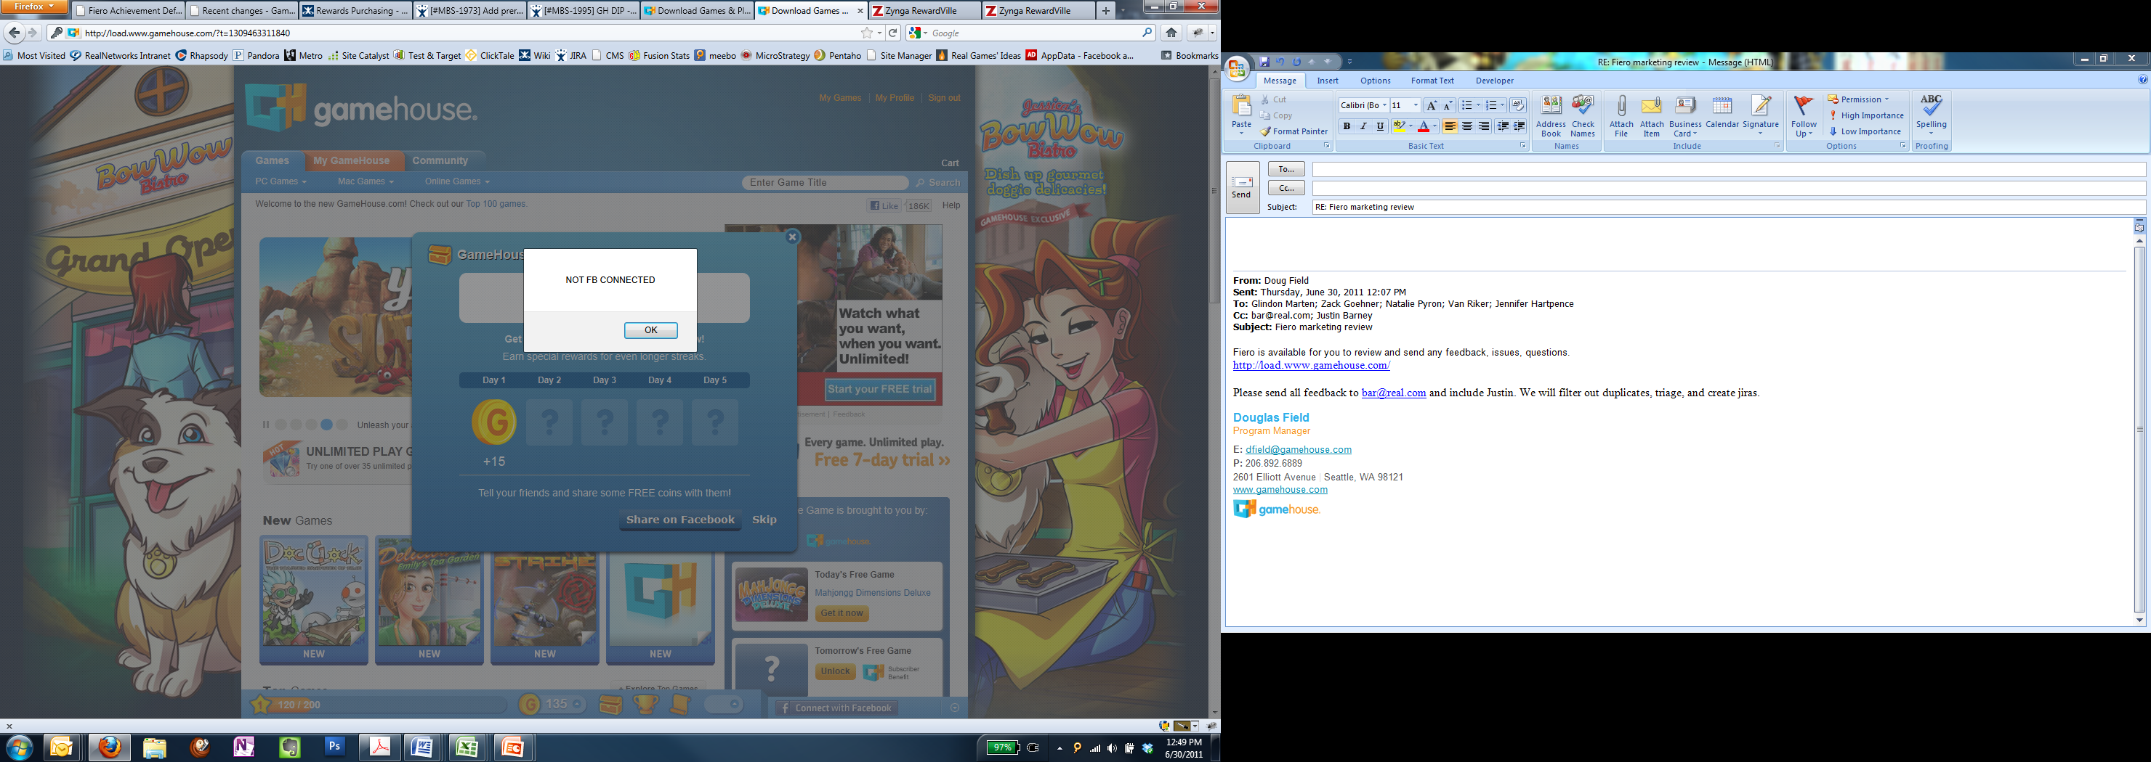

1. When I am FB connected I still receive the same error message above that says I’m not connected.
2. We need to update the logo on the Activity Feed toast icon. I’m not sure if there are other places that use this.

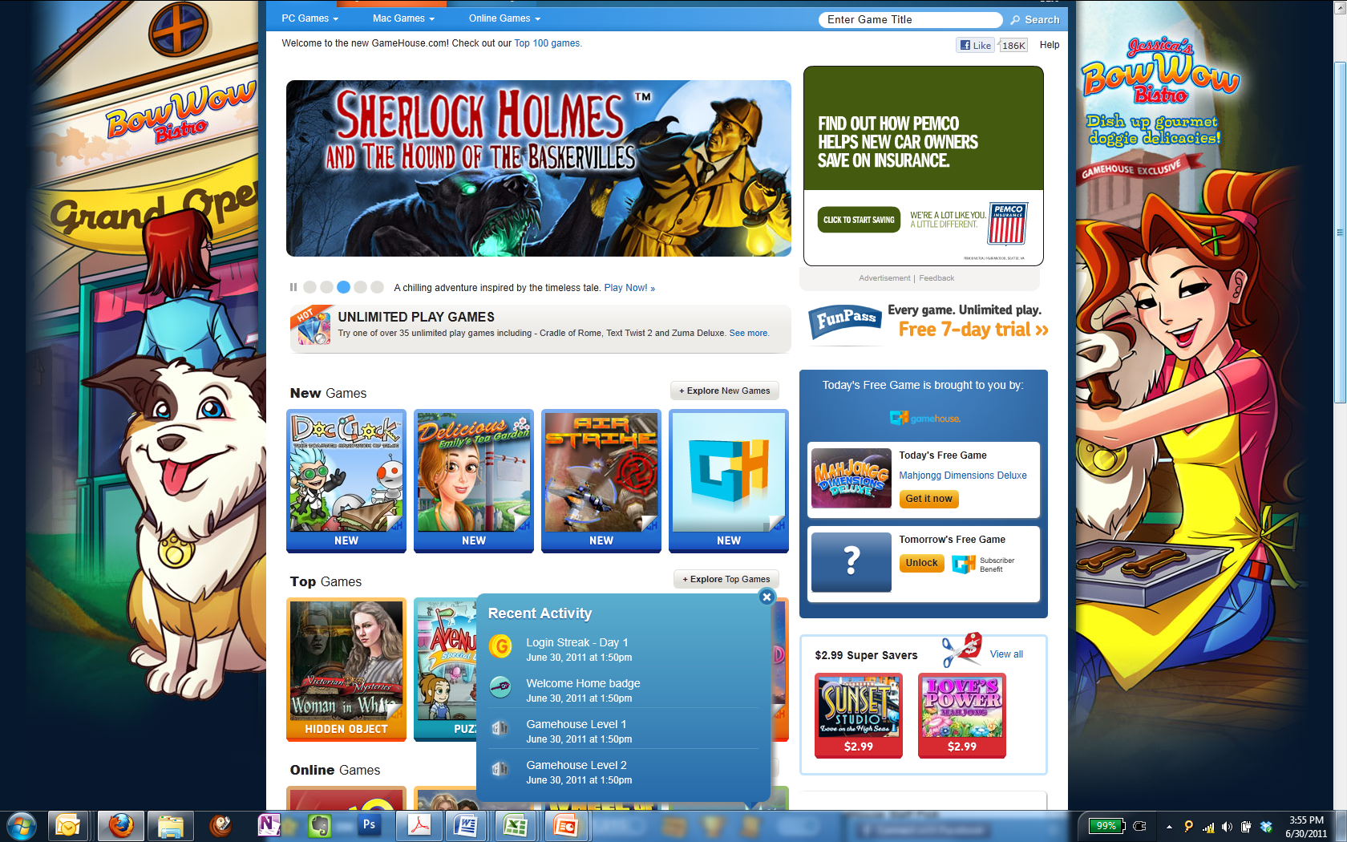

1. Also, the badge icons being used in the Recent Activity are the 64x64 scaled down. We should be using the 40x40 or 16x16 images provided by Glin to uphold the integrity of the design.
2. I think we have a default image for Recently Played which is currently missing.

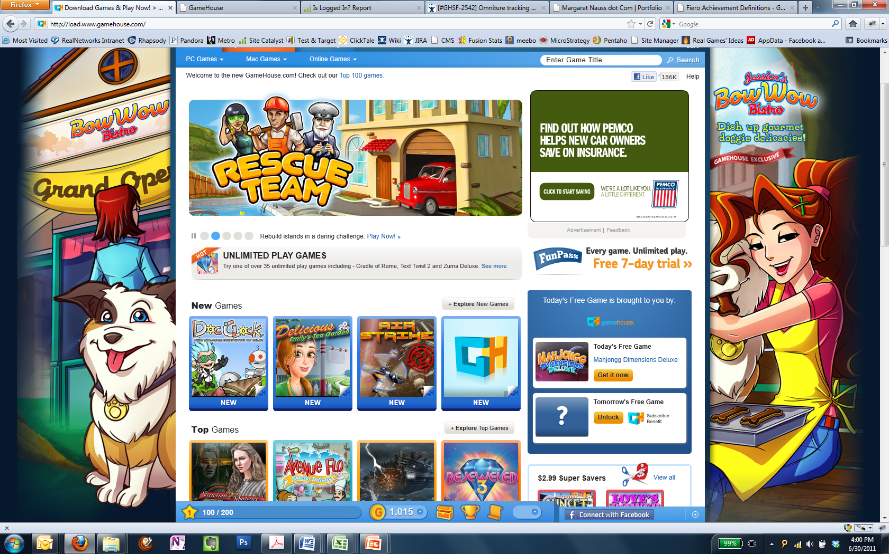

1. My Badges page
   1. Alignment is off for the copy under the header. This is same on My Rewards page.

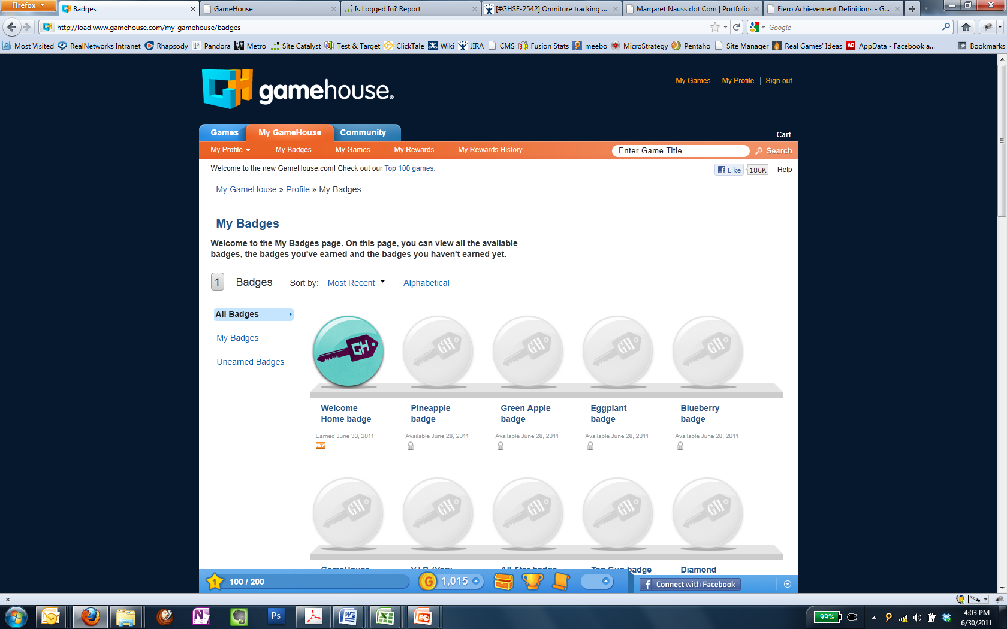

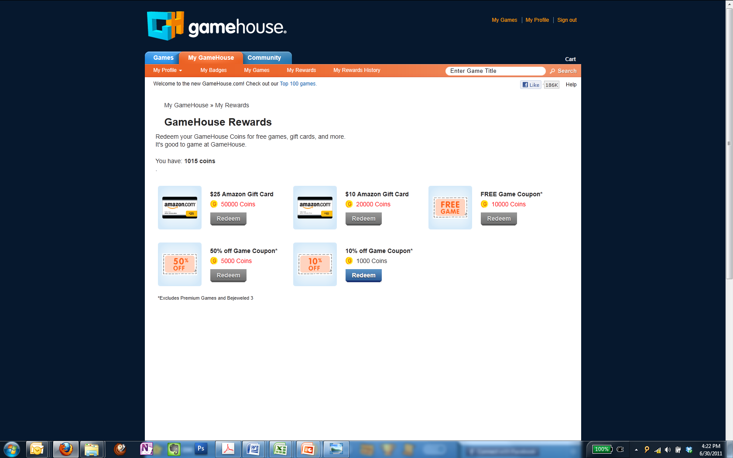

* 1. The header and badge name should not be a non-link color since it’s not clickable.
  2. The placeholder image needs to be used for those that are locked/unearned.

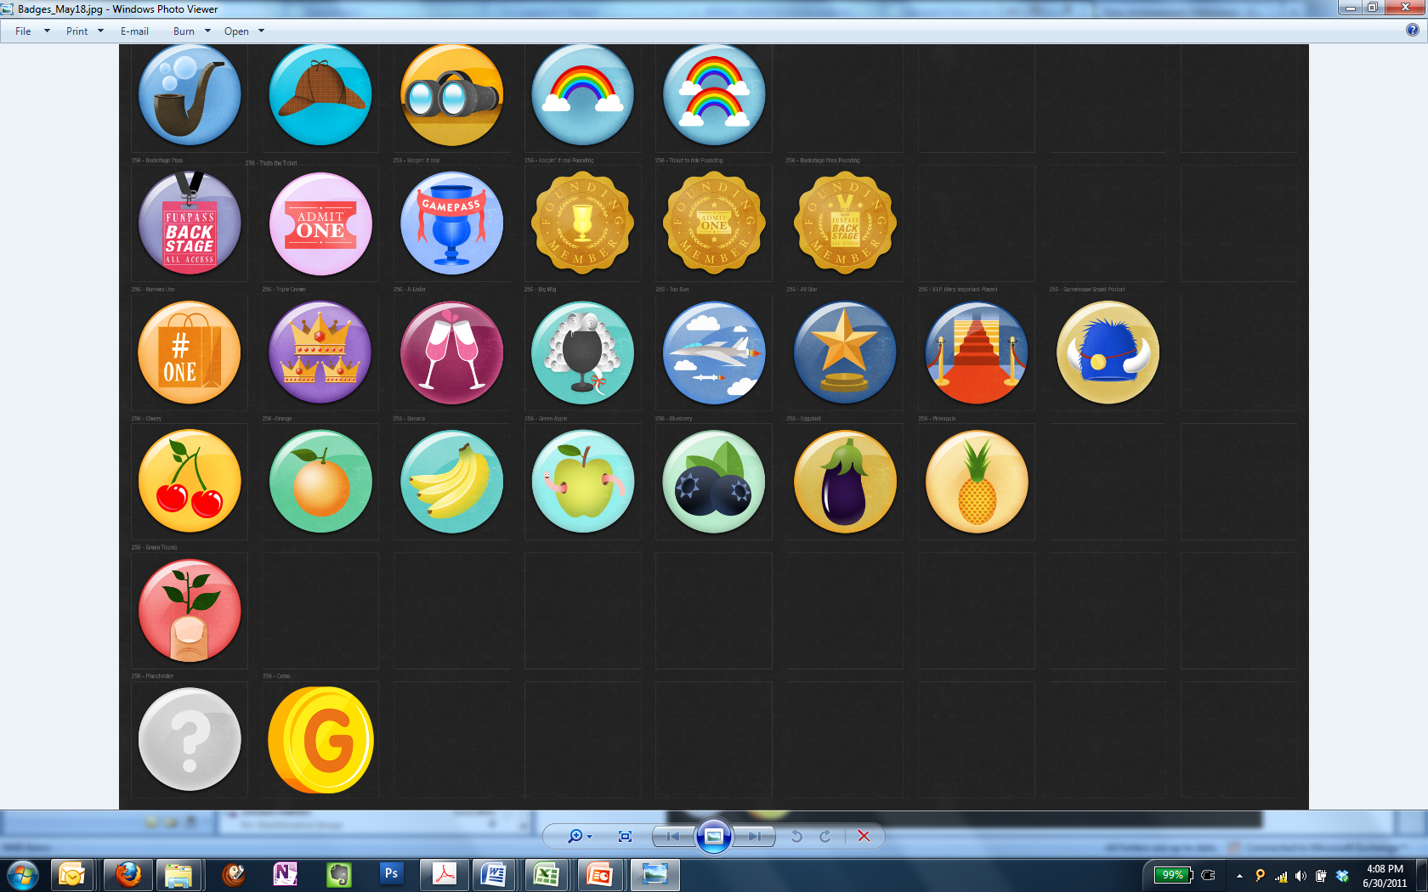

* 1. I’d like to also confirm that all badges are using the art which was delivered on May 18. There have been changes, including swapping the old with the new logo. It looks like an old batch of badges are being used.

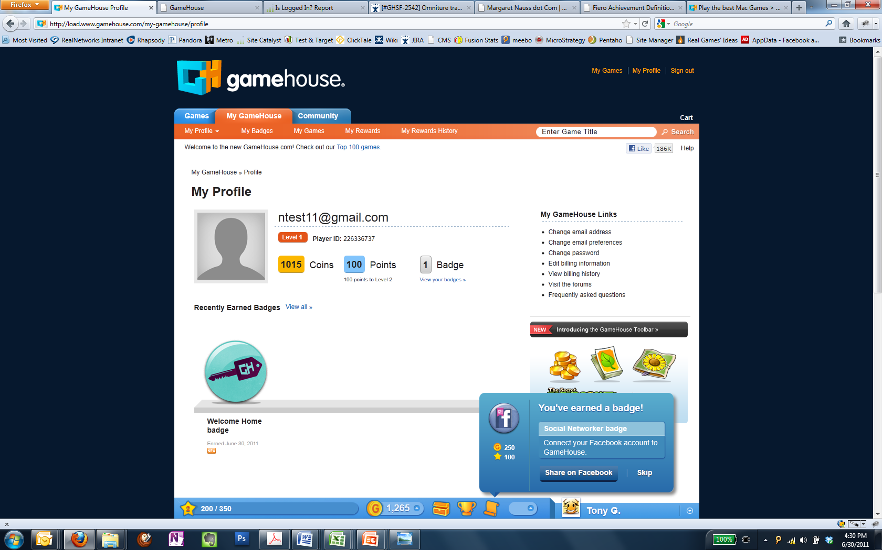

1. Can we update the following design to match the look-and-feel of the new account page? This was not accounted for. (see Zack)

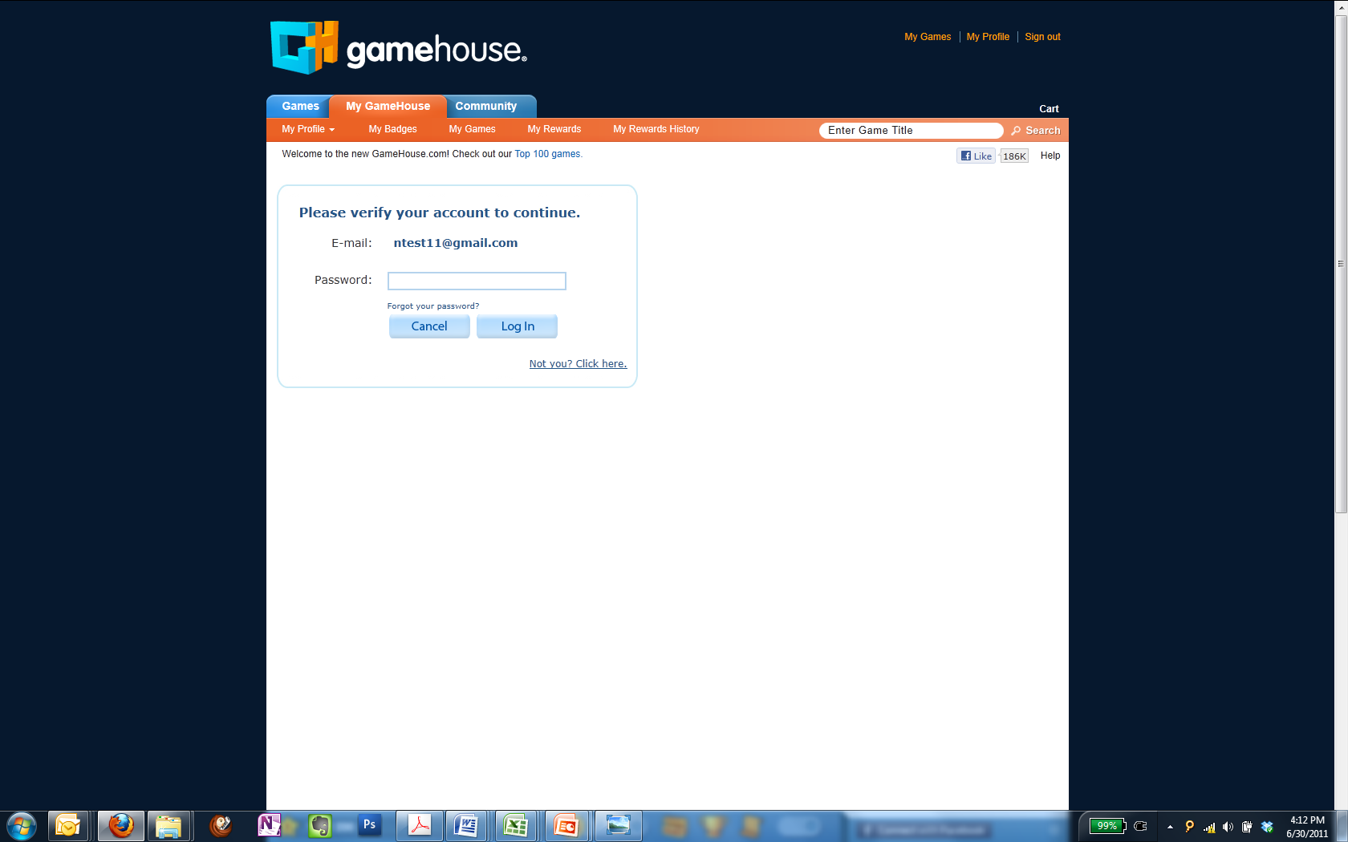

1. We need to replace the SPS image or disable it for launch. (Natalie)

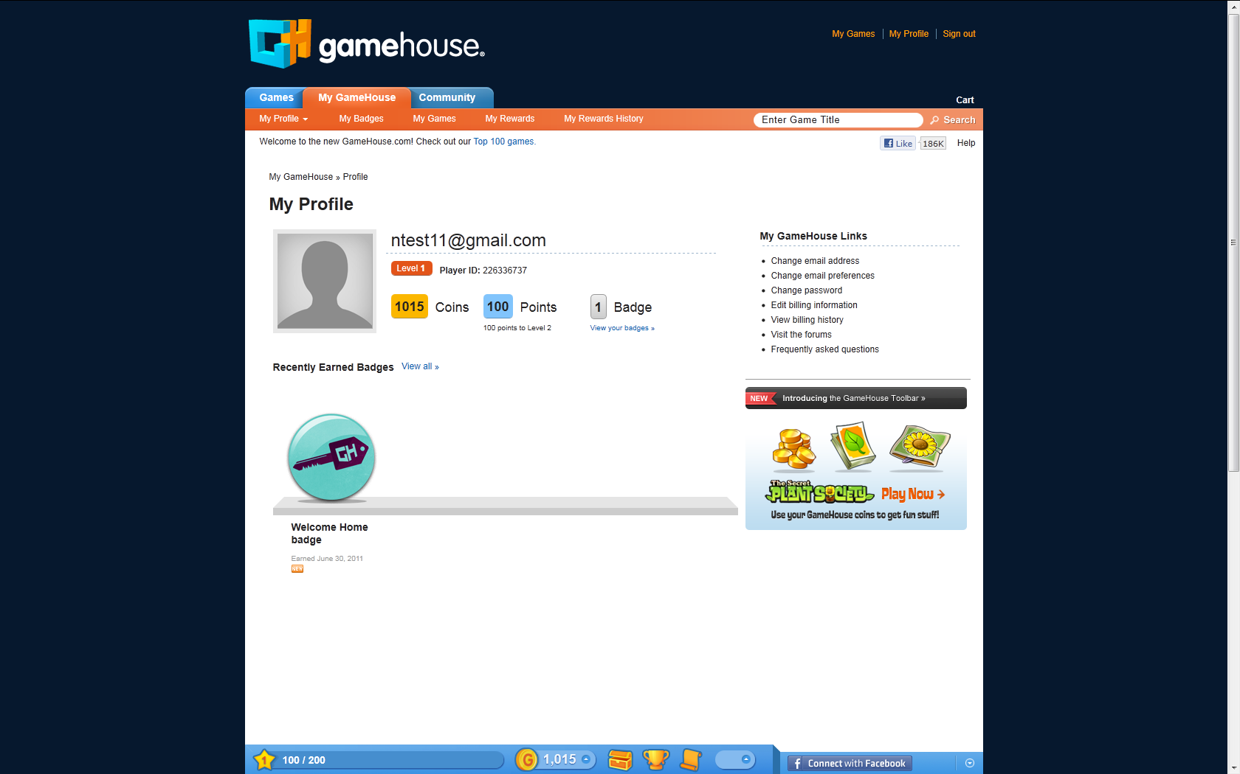

1. On My Profile, once I’m FB Connected it show my pic but it’s stretched out because we’re using the same 50x50 as used in the toolbar. Can we pull in the larger FB image so it’s not stretched?

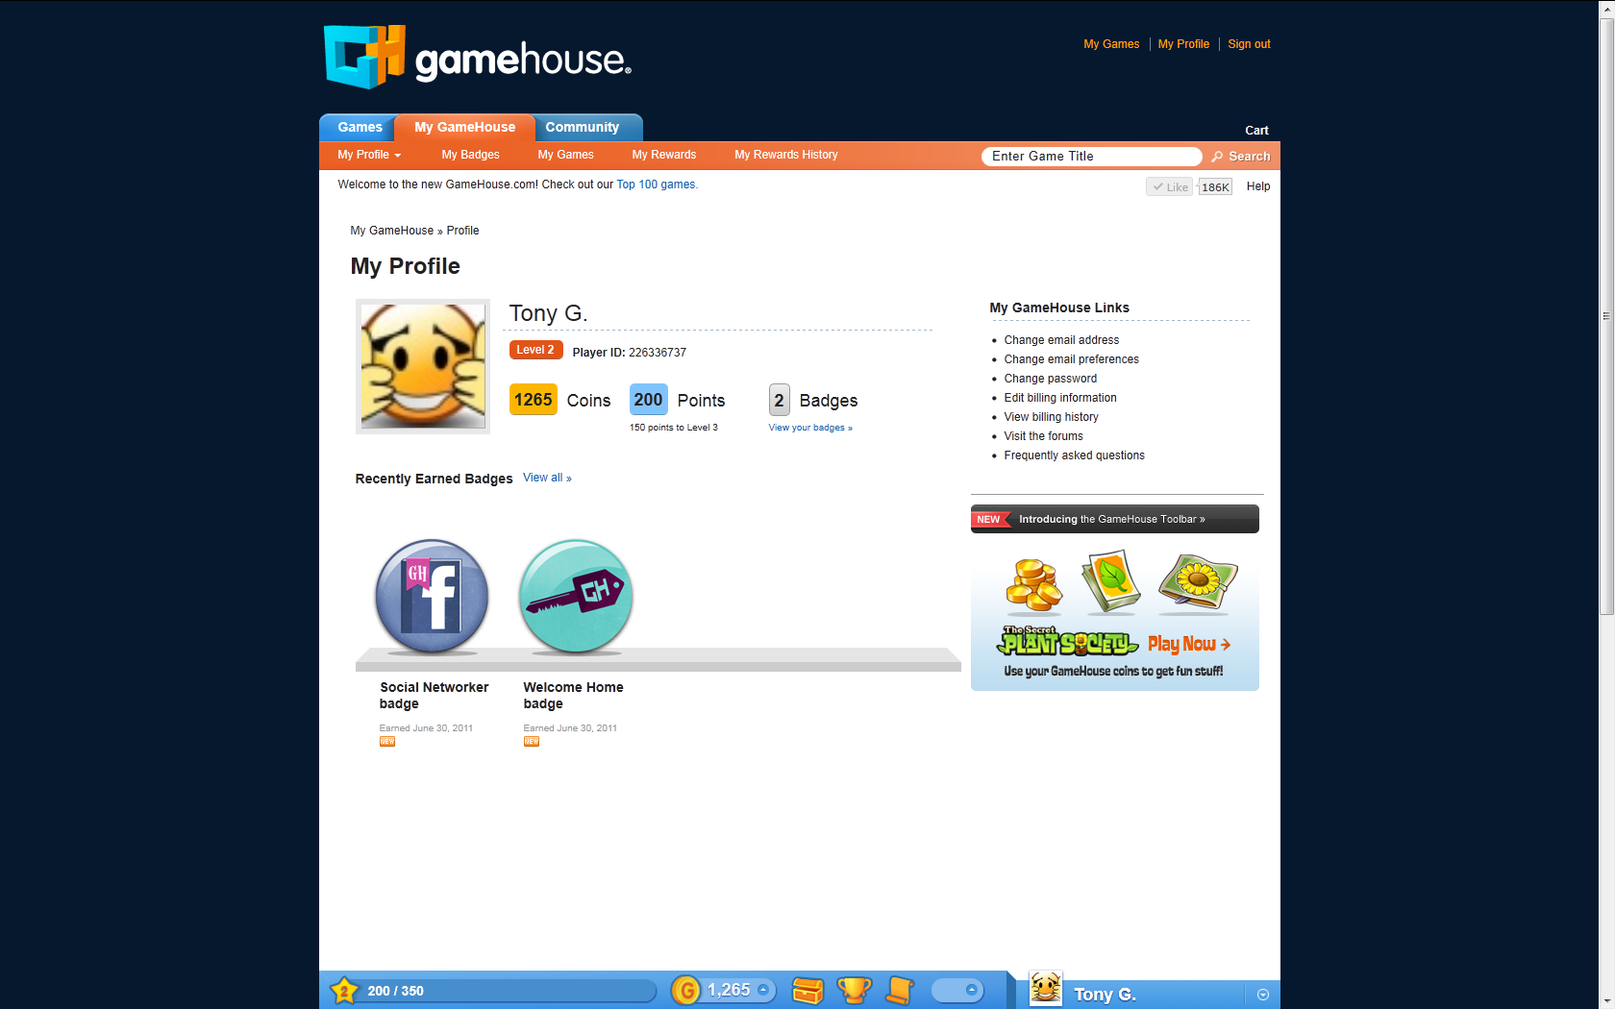

1. When I sign out of the site, it doesn’t sign me out of Facebook. This is a P0 requirement.
2. In general, the My GameHouse pages don’t use the correct default background. (See production: <http://www.gamehouse.com/mac-games>)
3. I think the styling and number of links under the “My GameHouse Links” is not correct. (Please verify with Zack.)

|  |  |
| --- | --- |
| On Load | Original Mockup |
|  | C:\Users\user\Desktop\Fiero Mockups_2011-06-14\My GameHouse pages\my-gamehouse_2011-04-04.jpg |

1. My Games
   1. The header for My Games should be a non-link color.
   2. We should remove the left column and 728x90 ad, and left-align the content like the other My GameHouse pages.
2. My Rewards flow
   1. Need to adjust text alignment (see Zack).

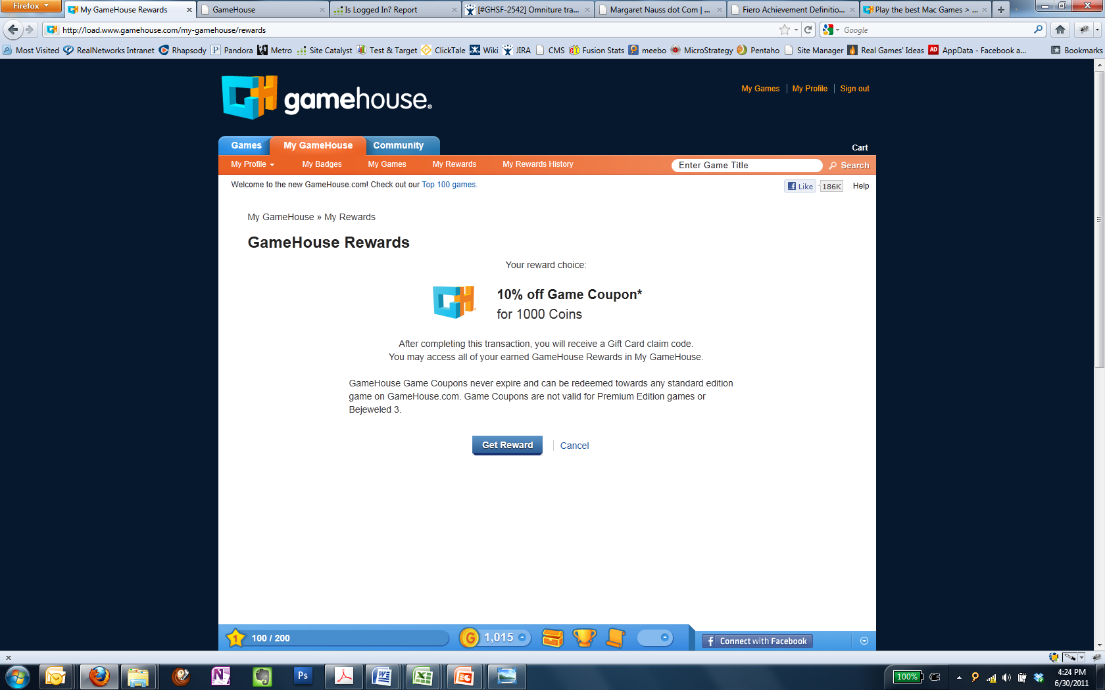

* 1. When I clicked “Get Reward” for the game coupon, it took me to the Amazon receipt page.

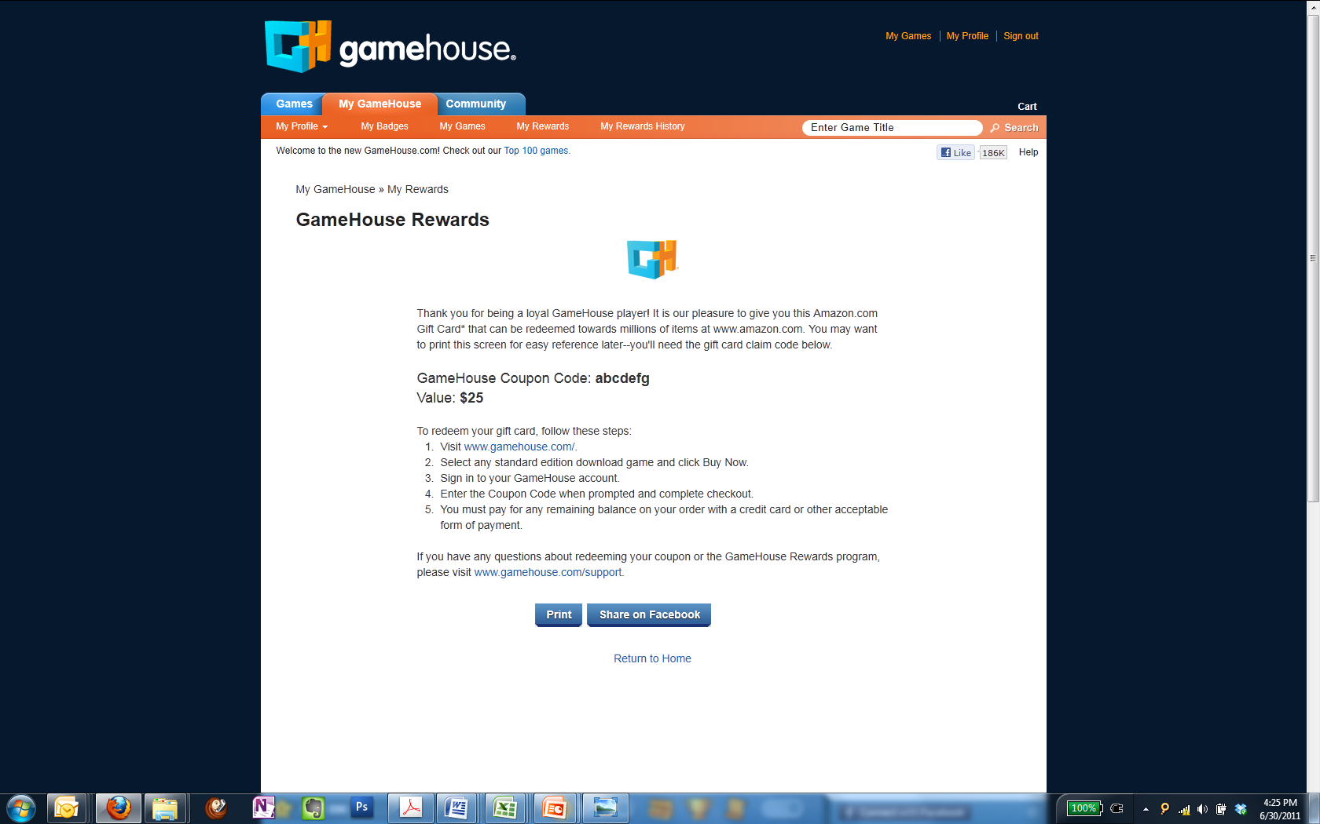

* 1. The “Share on Facebook” button and “Return to Home” links took me to the My Rewards page. The support link is also not directing me to the correct place.
  2. Breadcrumbs are inconsistent (larger font) than rest of site.

1. When I play my first online game, it gave me the daily bonus overlay.

Also, I noticed the 150x150 on the homepage merchandised the standard UNO online game but took me too Boost. I received a badge without even playing the game.

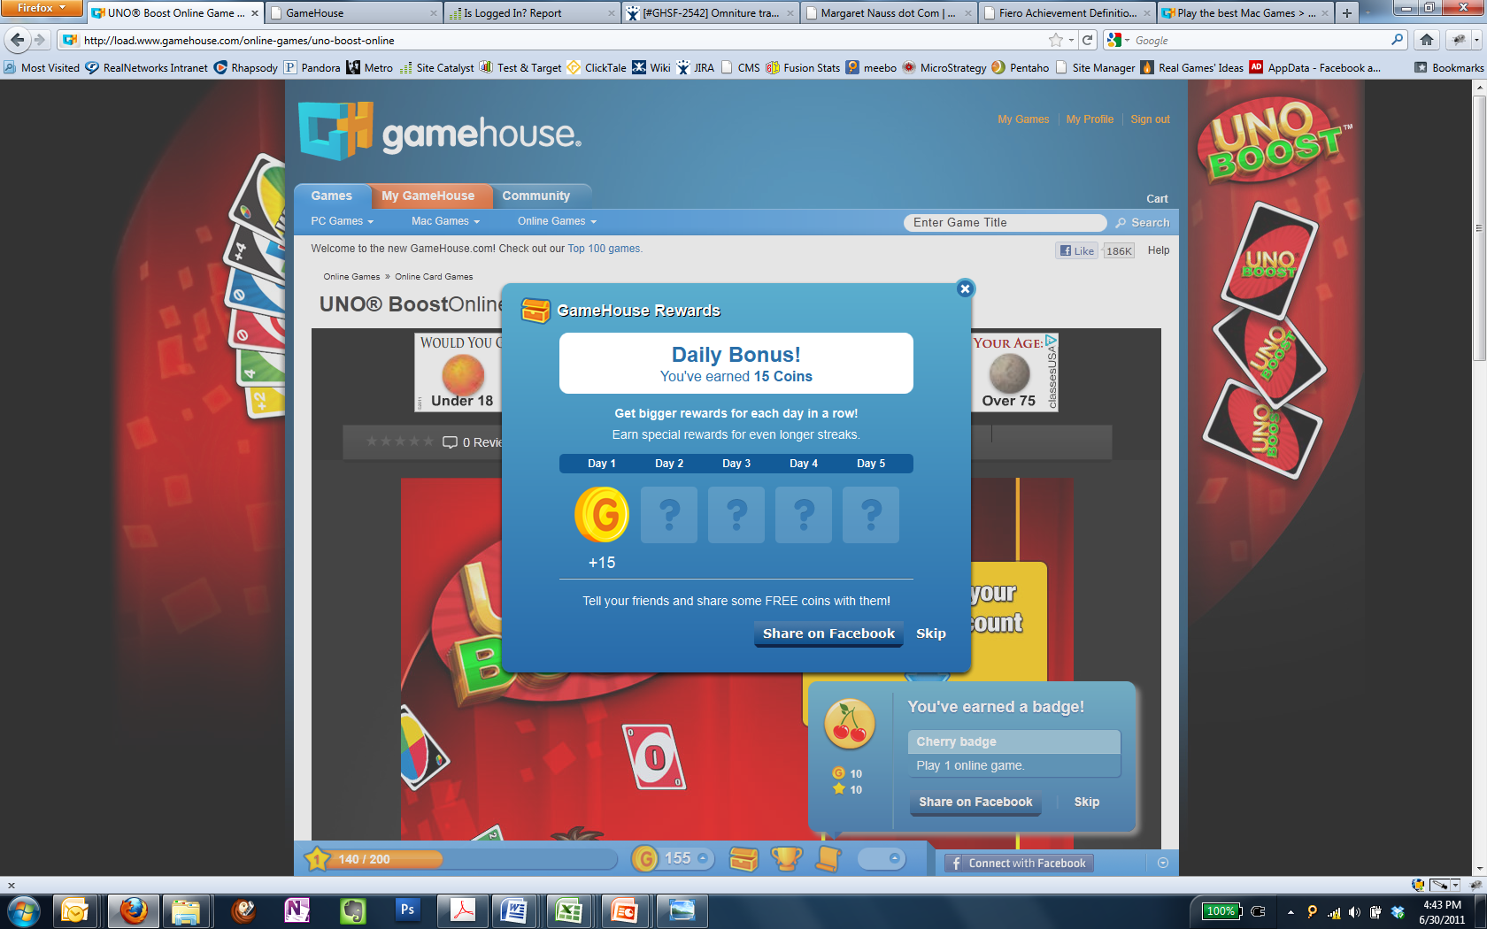

1. Recently played is not listing any games after I tried about 3. Also, it needs a hand icon when you mouseover the icon similar to the other icons on the toolbar. It’s currently an arrow.

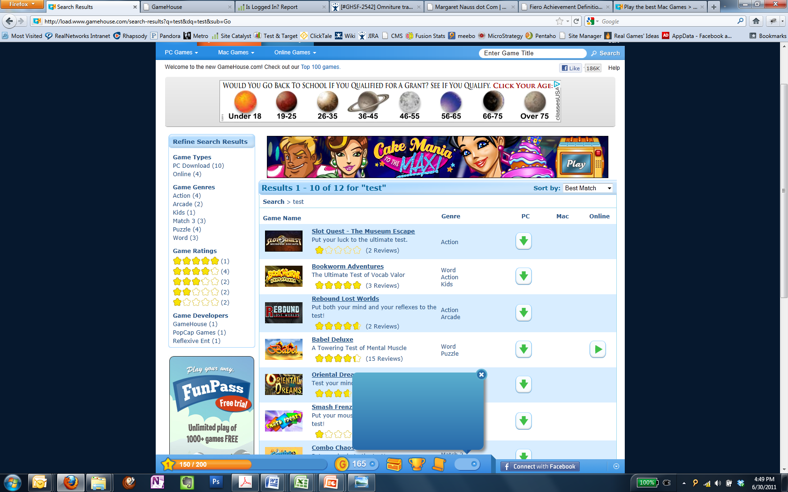

1. The toolbar isn’t showing on download product detail pages.